IME 458 - Microelectronics and Electronic Packaging

Project Proposal

OnyxPSU

Reprogrammable Power Supply and Distribution Subsystem

Quinn Mikelson

Sophomore of Electrical Engineering

California Polytechnic State University

San Luis Obispo, CA

Email: [qmikelso@calpoly.edu](mailto:qmikelso@calpoly.edu)

Cell: 805-878-0829

Last Updated: January 15th 2017

Note: All hyperlinks included in this document will be referenced on the final page, this document is subject to revision.

***Project Overview***

Onyx is the project title for my research into quadrupedal robotic locomotion. It also serves as an Electronics Design and Linux Development platform. OnyxPSU is designed to integrate into this project as a key module.

The Onyx project itself is discussed in several other documents, and is split into multiple different sub-projects. The goal of this specific paper is to outline my proposal for the power distribution and signal routing system designed to slot into the BeagleBone Black embedded Linux Single Board Computer (SBC).

The SBC provides hosting and control functionality as well as wireless communications and programming support. The power distribution system, as it stands, uses five separate modules (Fig. 2-4) in various states of modification and functionality. My goal for OnyxPSU is to combine these modules as well as add battery-charging support and a few other safety and protection features to increase the reliability and efficiency of my robot. By combining reference and open-source designs, a 10-week development period is sufficient; I see little logistical issue with the design, fabrication, testing, and implementation aspects.

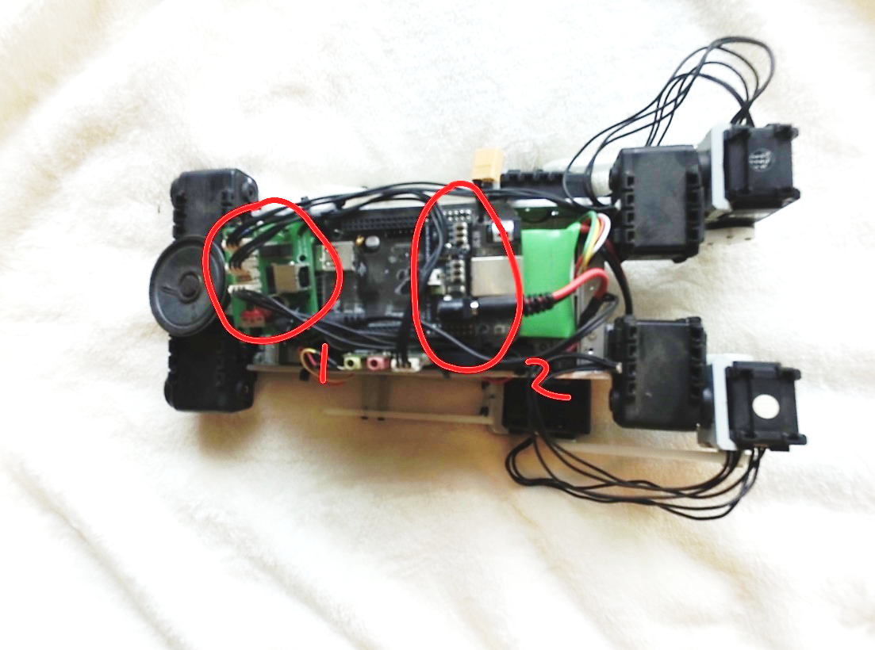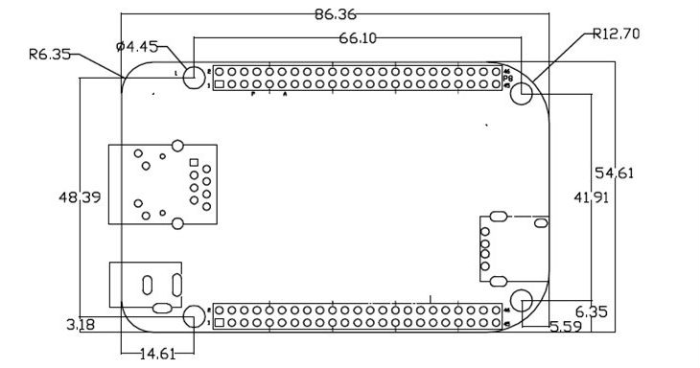

(Fig. 1) BeagleBone Black (SBC)

(Fig. 2) 1: Actuator Control Block

2: SBC LV Regulation

***Project Functionality Proposal***

* Fits Standard BeagleBone “Cape” footprint (See Fig. 1)
* Voltage and Current Monitoring
* Battery Charging and Health Monitoring
* High Current Discharge to Multiple Subsystems
* Voltage and Power Regulation
* Reverse Polarity, Overvoltage, Thermal, and Brownout Protection
* Reprogrammable ATMEL System Supervisor (Watchdog)
* Serial Communication Bus for I2C and/or SPI
* EEPROM configuration and Diagnostic Storage
* Low Current Consumption and Power Mode Cycling
* Actuator Breakout and Power Distribution
* RTC

**STRETCH GOALS:**

* USB to I2C Actuator Control (Proprietary Servo Control Protocol)
* Bluetooth Serial Transceiver
* I2C, CAN, UART, AND SPI Communication Support
* Digital Potentiometer and Configuration Utilities
* Demonstration Software
* Harsh Environment Hardening
* Independent Power Subsystem control

I’ve got my work cut out for me here, but I’ve already finished with most of the planning and design. The OnyxPSU system lacks RF components as of now, so the most important design considerations are thermal management and noise reduction. I feel confident in my ability to produce this module, but I may be lacking on the demonstration side; if all goes smoothly, nothing exciting should happen.

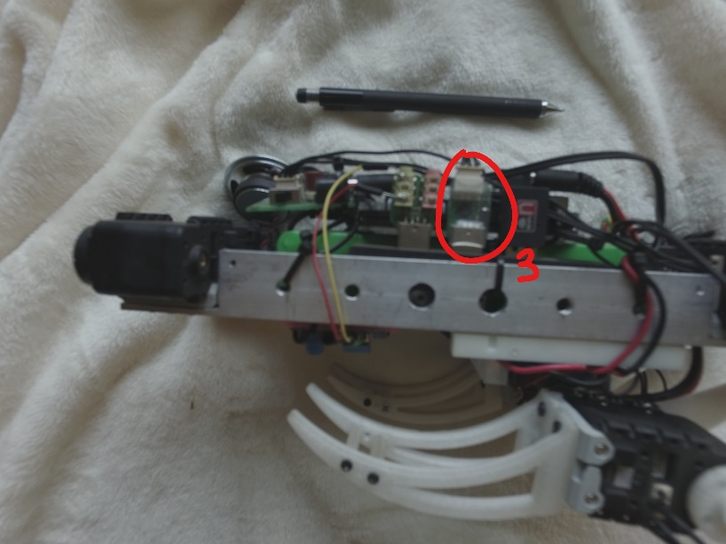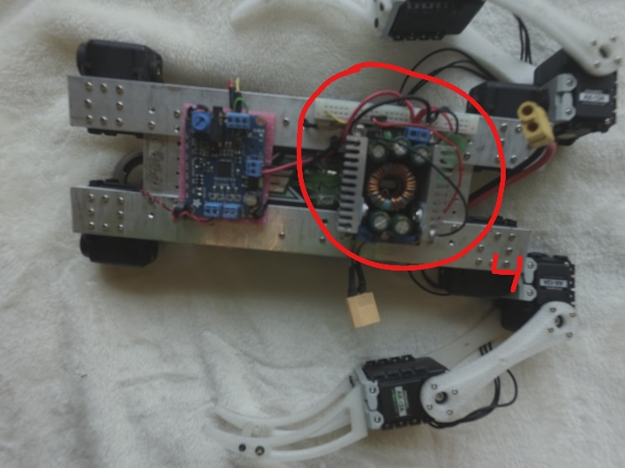

(Fig. 3) 3: USB to Proprietary I2C

(Fig. 4) 4: HV Power Supply

***Design Considerations***

The power supply does have a few challenging design aspects of which I’d like to reference here in bulleted format as well as include proposals for solutions.

* Large number of onboard connectors may cause limited space issues
* Large current draw through primary regulators (12,140mA peak projected draw @ 15V)
* Thermal considerations for optimal component placement and functionality
* Multiple onboard switching regulators
* Board density and assembly order

The onboard switching regulators are going to generate noise and the power FETs are going to dissipate a non-trivial amount of heat energy, so careful placement of power components will be required. The board may need to be sectioned into a low-noise logic side, and a high power side. Large cooling fins should be avoided if at all possible to keep board footprint as small as possible. Peak projected draw was measured with a bench power supply and the robot under full load. Design should account for up to 15,000mA peak current to avoid any future power constraints. The design is supposed to allow for rapid module replacement; careful consideration of connectors will be key.

***Block Diagram***



***Functional Description***

The battery feeds into a charging IC which handles trickle charging and reports diagnostics to the voltage monitoring IC. The voltage monitor IC feeds data over an I2C bus to the MCU. The charge controller feeds power into the voltage conversion network which relays regulated current to the switching network for the various on-board subsystems.

The MCU reports to the SBC and makes sure everything is running properly. The MCU should always stay powered on at least in a hibernation state. At hibernation the MCU is rated to draw an extremely small (~ .7μA) current. The MCU handles SBC power up and shutdown procedures and keeps track of timing with an RTC function. The firmware I intend to use is already written, it just may need to be adapted to this exact board.

The board keeps track of device ID’s, diagnostic, configuration, and miscellaneous data in the EEPROM. Indicators are still being decided upon, but LEDs are certain to be included in the final design.

***Prototype Schematics***

Table 1: Projected expenses (Per Board)

|  |  |  |  |  |
| --- | --- | --- | --- | --- |
| Component | Individual Cost | xQ | Total | Reference |
| BQ24610 PMIC | 7.06 | 1 | 7.06 | http://www.digikey.com/product-detail/en/texas-instruments/BQ24610RGET/296-25611-1-ND/2202277 |
| ATXMEGA32E5MCU | 2.34 | 1 | 2.34 | http://www.digikey.com/product-detail/en/microchip-technology/ATXMEGA32E5-AUR/ATXMEGA32E5-AURCT-ND/4119400 |
| TPS63061 BBC | 2.60 | 1 | 2.60 | <http://www.digikey.com/product-detail/en/texas-instruments/TPS63061DSCR/296-30205-1-ND/2834997> |
| INA230 PMIC | 2.83 | 1 | 2.83 | http://www.digikey.com/product-detail/en/texas-instruments/INA230AIRGTR/296-36594-1-ND/4341290 |
| MCP1702 LDO | .49 | 2 | .98 | http://www.digikey.com/product-detail/en/microchip-technology/MCP1702T-3302E-CB/MCP1702T-3302E-CBCT-ND/1979828 |
| ATMega32u2 MCU | 3.07 | 1 | 3.07 | http://www.digikey.com/product-detail/en/microchip-technology/ATMEGA32U2-AUR/ATMEGA32U2-AURCT-ND/3789462 |
| Sample FET | ~.70 | 10 | 7.00 |  |
| MISC SMD | .2 | 50 | 10.00 |  |
| MISC CW Inductor | 1.25 | 4 | 5.00 |  |
| MISC CMPNTS |  |  | 10.00 | Added for unforeseen expenses |
|  |  |  |  |  |
| Subtotal |  |  | 50.88 |  |

***Plain Text References***

[Andice Labs Power Cape](http://andicelabs.com/shop/andicelabs/beaglebone-high-power-cape-1a-charge-rate/)

<http://andicelabs.com/shop/andicelabs/beaglebone-high-power-cape-1a-charge-rate/>

Andice Labs provides open-source schematics and firmware for the watchdog part of my circuit, design considerations were also made with some of their schematics as reference.

[USB2AX Project](http://www.xevelabs.com/doku.php?id=product:usb2ax:usb2ax)

<http://www.xevelabs.com/doku.php?id=product:usb2ax:usb2ax>

One of my stretch goals (but in my opinion the most important feature), prototype USB to I2C transciever. 1Mb/s transfer of proprietary data communication protocol for the Dynamixel AX12A Servo motors used in the limbs. Also fully open-source.